Job Listings Analysis Dashboard

Overview
This project involves creating a Power BI dashboard to analyze job listings. The dashboard provides insights into the count of jobs based on job titles, average yearly salaries by job title, job locations and their average yearly salaries, in-demand skills for each posting, and the count of remote jobs by location.

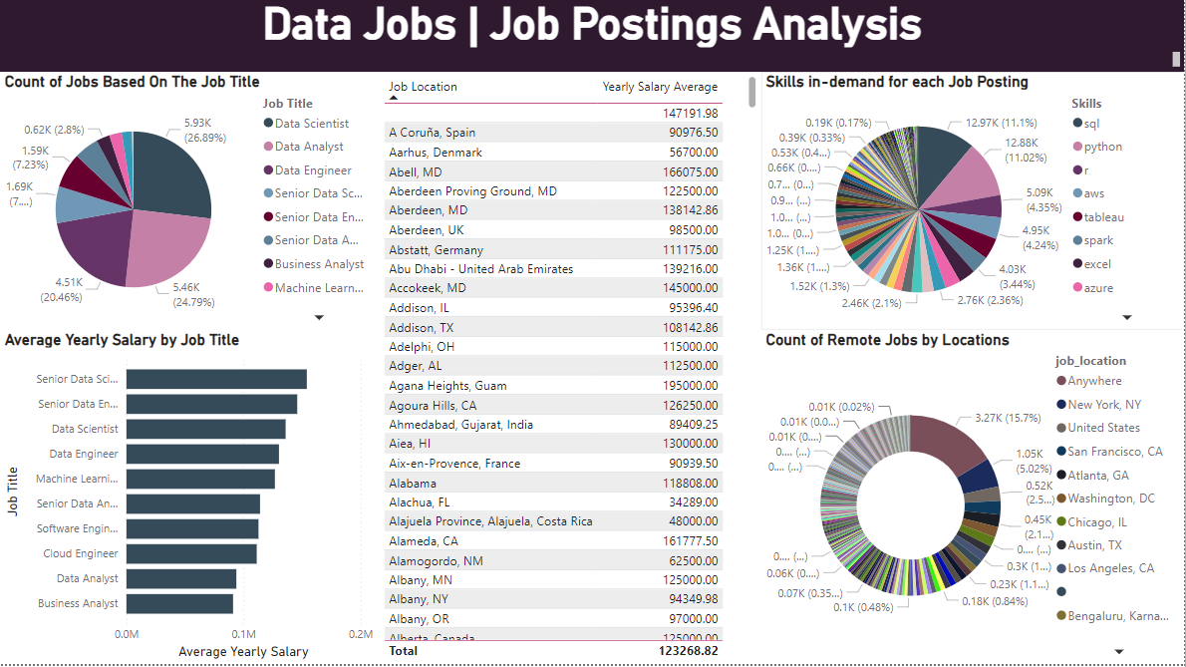

Data Collection
The data for this project comprises job listings related to various roles. The data was sourced from various job boards and compiled into a single dataset.

Dashboard Creation
The analysis results were visualized using Power BI to create an interactive dashboard. The dashboard includes:
- Count of Jobs Based on Job Title: A Pie chart showing the number of jobs for each job title.
- Average Yearly Salary by Job Title: A bar chart displaying the average yearly salary for each job title.
- Job Location and Its Yearly Salary Average: A Table visualization showing job locations with their corresponding average yearly salaries.
- Skills In-Demand for Each Posting: A Pie chart listing the most in-demand skills for job postings.
- Count of Remote Jobs by Location: A Donut chart indicating the number of remote jobs available by location.

Results
The dashboard provides the following insights:
- The distribution of job listings across different job titles.
- Average salaries for various job titles.
- Geographical distribution of job listings and their average salaries.
- In-demand skills for different job postings.
- The prevalence of remote jobs in various locations.

Conclusion
This project highlights key trends and insights in job listings, helping job seekers understand the job market better and employers identify what skills are in demand. The interactive dashboard serves as a valuable tool for visualizing and exploring the data.

